The Post-Amplifier/Optical Transmitter (PAX) Assembly
4.1.1.2.1 : SP-ASP-FE-PAC-PAX

April 3, 2006 – DRD

0 Introduction
The post-amplifier/optical transmitter (PAX) assembly sits immediately behind the feed in the PAX case (PAC) and accepts the dual polarization output from the feed. It amplifies the RF signals and transmits them back to the lab via optical fiber.

The PARTS entry for the PAX may be found at:
– list entry –
http://intranet.seti.org/docs/ata/PARTS/SP/ASP/FE/PAC/PAX/ListPAX.shtml
– datasheet -
http://intranet.seti.org/docs/ata/PARTS/SP/ASP/FE/PAC/PAX/AssemblyPAX.shtml

This write-up subsumes previous documents, including:
PAX Front Panel.doc
PAX Wiring.doc
OTX Interface Document 3-17-2004.doc
dewarPAXpinout.doc

1 PAX Interface

Figure 1.1 below shows the front-panel of the PAX (which actually faces away from the feed) and the tables below give the pin-outs for the two filtered D-connectors.
Y-pol fiber out
X-pol fiber out
Y-pol RF in
Control POF
Pin 1
X-pol RF in

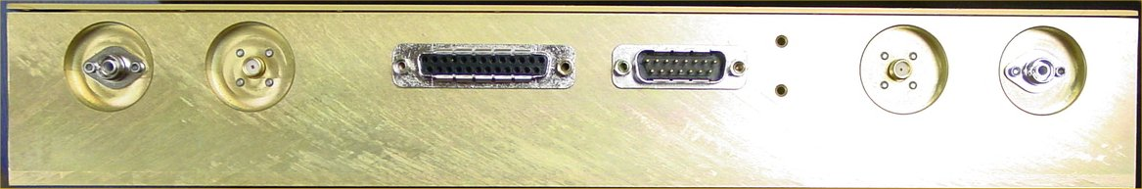
Y
X
D25S
D15P
Figure 1.1: Annotated picture of the “front-panel” of the PAX box.

D25S – powers LNA’s from PAX control board. Connects to dewar.
D15P – powers PAX from rim power box (and temperature input). Connects to bottom of PAX case.

*Pin-out D25S |  |  | *Pin-out D15P
1 | GND |  | 1 | GND
2 | Vdrain Y |  | 2 | +5 (OTXTEC)
3 | GND |  | 3 | GND
4 | Future |  | 4 | +6 (OTXlaser/PAM)
5 | Future |  | 5 | GNDsense
6 | Vgate X |  | 6 | +6sense
7 | GND |  | 7 | +5sense
8 | GND |  | 8 | -6sense
9 | Vdrain X |  | 9 | +5 (OTXTEC)
10 | NC |  | 10 | GND
11 | Future |  | 11 | -6 (OTX/PAM)
12 | NC |  | 12 | GND
13 | NC |  | 13 | GND
14 | Vminus Y |  | 14 | T
15 | GND |  | 15 | +5 V out to T
16 | GND |  | See also section
17 | Vgate Y
18 | Future
19 | Future
20 | GND
21 | Vminus X | *Colored pairs denote twisted pairs.
22 | NC
23 | Future
24 | NC
25 | NC
See also section 2.1

1.1 Connectors

The RF in connectors are SMA, part number XYZ.

The optical fiber connectors are for FC/APC, part number XYZ.

The D25S connector, which provides power for the LNA, is a filtered Dsub connector, part number XYZ.

The D15P connector, which provides power to the PAX from the rim power box as well as thermistor temperature data for the TEC’s, is a filtered Dsub connector, part number XYZ.

1.2 Signal Levels

RF input levels

Optical output levels

1.3 Power

Power requirements/constraints

2 Cable from PAX to Rear of Dewar
All pairs (#/#) are twisted pairs. The overall finished cable should be 62″ ± 2″ from connector face to connector face.

2.1 25-pin Dsub pinout

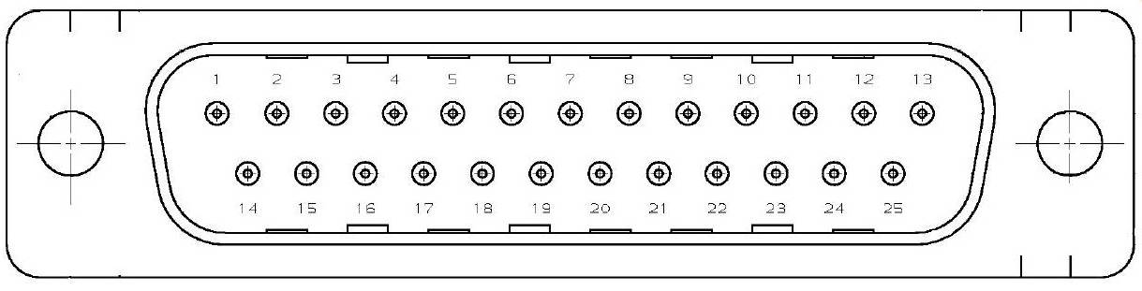

Type | Pins | Function | Pins | Function | Pins | Function
Case | 1 | Gnd
LNA | 2/3 | VdrainY/Gnd | 6/7 | GateX/Gnd
LNA | 14/15 | VminusY/Gnd | 8/9 | Gnd/VdrainX
LNA | 16/17 | Gnd/GateY | 20/21 | Gnd/VminusX
Other | 4/5 | Future | 11/23 | Future
Other | 18/19 | Future

2.2 21–pin Micro-D pinout:
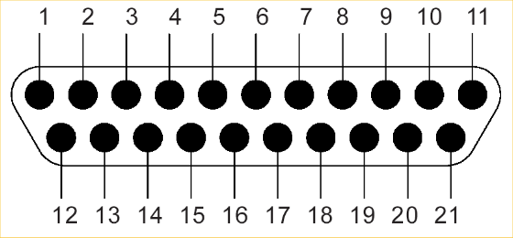
Split out of cable and go directly to connector on bottom of PAC.

Type | Pins | Function | Pins | Function | Pins | Function
Case | 1 | Gnd
LNA | 2/3 | VdrainY/Gnd | 6/7 | GateX/Gnd
LNA | 12/13 | VminusY/Gnd | 8/9 | Gnd/VdrainX
LNA | 14/15 | Gnd/GateY | 18/19 | Gnd/VminusX
Dewar temp |  |  |  |  | 11/21 | Temp +/-
Other | 4/5 | Future | 10/20 | Future
Other | 16/17 | Future

Pin-out by number
Micro-D21 | Function | Dsub25
1 | Case Gnd | 1
2 | Vdrain Y | 2
3 | Gnd | 3
4 | Future | 4
5 | Future | 5
6 | GateX | 6
7 | Gnd | 7
8 | Gnd | 8
9 | VdrainX | 9
 | N/C | 10
10 | Future | 11
 | N/C | 12
11 | Temp+ N/C | 13
12 | VminusY | 14
13 | Gnd | 15
14 | Gnd | 16
15 | GateY | 17
16 | Future | 18
17 | Future | 19
18 | Gnd | 20
19 | VminusX | 21
 | N/C | 22
20 | Future | 23
 | N/C | 24
21 | Temp – N/C | 25

3. PAX Interior

Figure 3.1 shows the interior of the PAX (an older version, but basically the same).

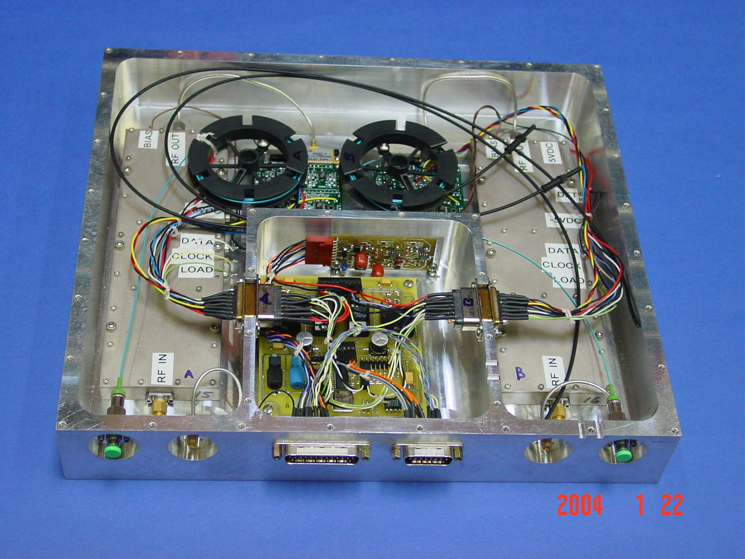
PAM-X
PAM-Y
OTX-X
OTX-Y
Control board
Figure 2: Interior of the PAX.

It is comprised of two post-amplifiers (PAMs), two optical transmitters (OTX) and a control board, which also supplies power to the LNA’s

Figure 3 shows the wiring from the 15-pin Dsub connector to the PAM/OTX
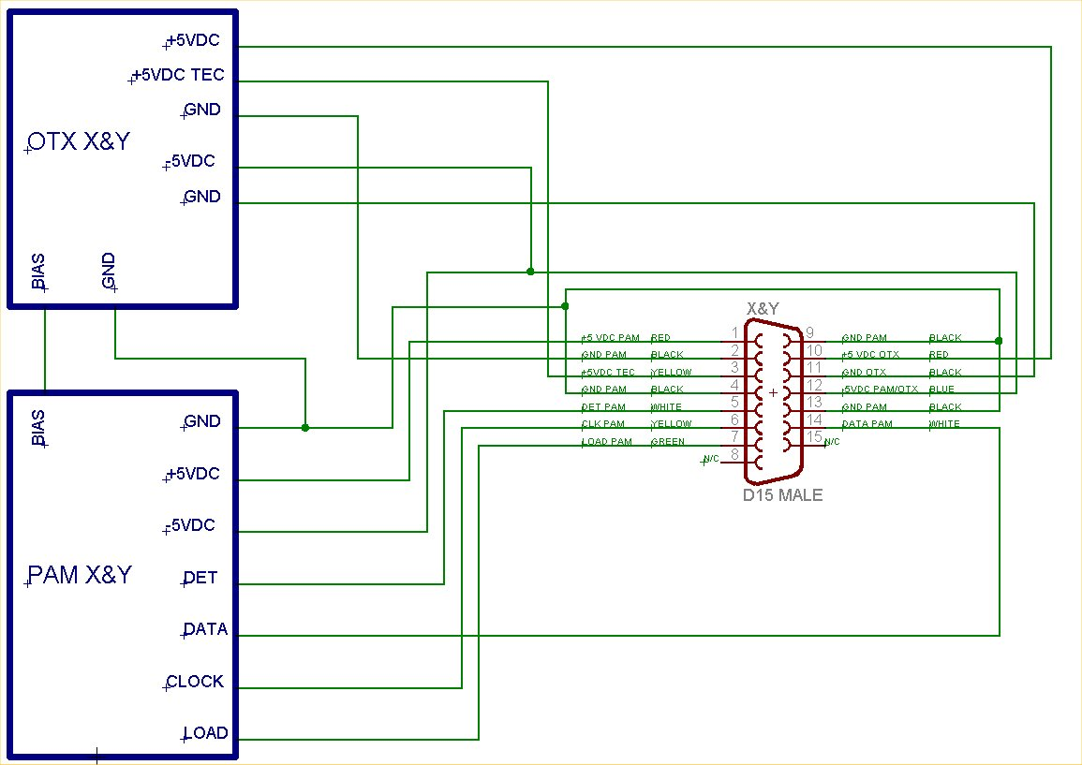
Figure 3:

3.1 Post-Amplifier Modules (PAM)

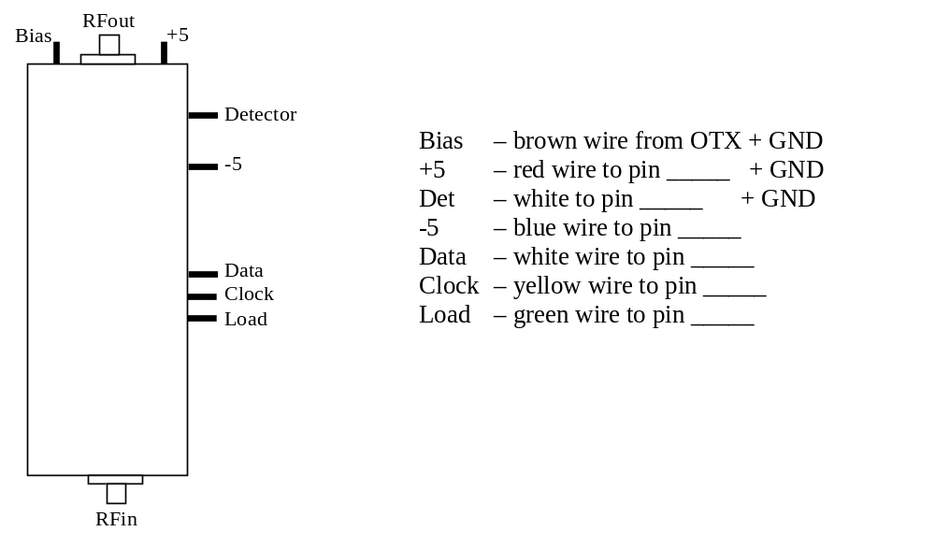

3.2 Optical Transmitter (OTX)

OTX Interface Document; March 17, 2004

Power supplies

+5 Laser 170mA max + 5V regulated laser bias total draw for both OTXs (2) in PAX
+5 TEC 532mA max +5V regulated TEC total draw for both OTXs (2) in PAX
-5 general 200 mA max -5V regulated total draw for both OTXs (2) in PAX

All the supplies will be linear type regulators.

Power supply pigtails: # 26 stranded wire; 15” long; color code:
Yellow+5 (TEC)
Red +5 (Laser)
Black ground
Blue -5
Regulation: PSI action to determine (to meet +/- 1% link gain spec)
Noise suppression:
UCB will include ferrite chips as part of there supplies
PSI will include power supply bypass capacitors to ground (10 μF, 0.1 μF) on all power supply lines. Electrolytic capacitor will be of a long life type

Mechanical

Dimensions: 2”x3” with fiber spool mounted above to accommodate fiber (with bend radius of 30mm) storage
Mounting holes (size, taped or clear) and locations: three holes taped 4-40 .25” deep in PAX plate to hold OTX down; see drawing EAM mod3 for hole locations.

Shock and/or vibration spec: TBD
OTX baseplate material: 0.125” jig-plate aluminum (for flatness, to insure good thermal contact with PAX plate)

Thermal

Nominal PAX cavity air temperature: 20 C
PAX cavity air delta-T: +/- 3 C
PAX cavity humidity spec: TBD
OTX EAM TEC temperature set point: set via top-adjust, 5-turn cermet potentiometer

Thermal grease to be used between all thermally conducting paths: i.e. between laser and OTX base plate, TEC controller and OTX base plate and between the OTX base plate and the PAX base plate.

PAM/OTX interface

RF connector: semi-rigid coax w male GPO connector on end – for mating with female GPO on EML
OTX input impedance: 50 Ω
PAM output impedance: 50 Ω with output match to reduce mis-match with OTX
PAM maximum output: need to confirm that this will not damage OTX or provide overload protection at OTX input (PSI and SETI action item)
DC connectors: None
Vm bias:
Set via top-adjust, 5-turn cermet potentiometer.
Supplied from OTX board to PAM (like the other power supply leads, this twisted pair pigtail, # 26 stranded wire, 15” long, color code: brownfor Vm, black for ground
Over voltage protection for Vm provided on the OTX board via a zener (not on the PAM as described in the PAX meeting notes of Aug. 21, 2002.

OTX-Foyer fiber interface

Type: SMF 28
Connector: FC/APC; fiber pigtail on PAX, connector on Foyer
Fiber storage during shipping and installation: fiber reel mounted above OTX, high enough to clear PAM but low enough to fit under PAX cover (see drawing EAM mod3)

:Fiber pigtail length: 0.9 m
“Excess” fiber (enough to permit 1 future connector replacement) is to be stored in the OTX on fiber spool

Monitor & Control input/output

Monitor points available: (these could all be monitored via a single A/D and an analog multiplexer). Outputs buffered with op amps.

Laser CW optical power monitor (voltage proportional to optical power; 0 to 4 V)
Requires calibration table to convert voltage to optical power for each device
Vm (Modulator bias voltage)
OTX EAM TEC control loop: Thermistor voltage; 25 Deg C = 1.250 V

Possible control points: (Not implemented)
Laser CW disable – to turn laser on/off
Constant optical power feedback disable – to switch to constant laser current operation

Open OTX Design Issues

Constant optical power mode selected (operational mode now selected)
Determine degree of control required for +/- 1% link stability goal (fall back is +/- 3%) (PSI action item) (Lifetime test indicated +/-0.2 dB)

These issues addresses by new OTX board design.
Consider impact of relatively low rejection ratios on 6330 on operation and the alternative of using another chip or designing a controller from scratch
Check TEC controller to see if it suffers from any similar problems (PSI action item)

RF & Optical Specifications

PARAMETER VALUE

Bandwidth 0.5 – 12 GHz
Gain ≥ – 40 dB
VSWR ≤ 2:1 across BW
Noise Figure ≤ 45 dB
Third-order intermodulation-free dynamic range ≥ 100 dB in 1 Hz
1-dB compression dynamic range ≥ 130 dB in 1 Hz
Maximum fiber length ≥ 1 km
Fiber-optic connectors FC/APC

